Image classifictaion
Using machine learning algorithm

Anil Pavuluru
MCIS dept. Cleveland State University
Ohio, Cleveland, U.S.A

Abstract— In recent years, with the speedy development in digital content identification, the automatic classification of images became the most challenging task in the fields of computer vision. Automatic understanding and analyzing of images by the system is difficult as compared to human visions. Many Experimental tests to solve the issue in the existing classification system models, unfortunately, the outcomes are very narrowed on low primitive images. However, those approaches lack the accurate classification of images. In this paper, our system uses a machine-learning algorithm to achieve the expected results in the area like computer visions. Our system presents SVM and RF, a machine learning algorithm being used for the automatic classification of the images. Our system uses the Digit of MNIST data set as a benchmark for the classification of grayscale images. The grayscale photos in the records set used for education require extra computational energy for the category of pictures. By training the pictures the use of the SVM community we acquire the 98% accuracy bring about the experimental element it indicates that our version achieves excessive accuracy within the classification of images.
Keywords—Supervectormachince,computervision, machinelearning algorithm and Random forset.

Introduction
The digital world content is expanding nowadays the classification of images is done by machines as humans become an issue in the visual angle of machine indexing and retrieval systems. Computer vision is an interdisciplinary and subfield of artificial intelligence that aims to give the similar capability of a human to a computer for understanding information from the images. Several research efforts were made to overcome these problems, but these methods consider the low-level features of image primitives. low-level image features may not guarantee results accurate.
Image classification is a big problem in computer vision for decades. In the case of humans, the image understanding, and classification is done the very easy task, but in the case of computers, it is a very expensive task. In general, each image is
composed of a set of pixels, and each pixel is represented with different values. To use for future purposes to store images requires a large amount of data. Spaces for store data. For that thing, we need to perform high computational calculations. This requires systems with higher configuration and more computing power. In real-time to make decisions basing on the input is not possible because it takes more time for performing these many computations to provide results.
In [1], has discussed extraction of the features from Hyper Spectral Images (HSI) by using SVM and Random Forests machine learning concept. It also addresses the general issues. Between the HSI image features. From the angle of engineering, it seeks to automate obligations. That the human visual machine can do. It is involved with the automated image extraction, evaluation, and knowledge of beneficial facts with images.
In the last decade, several approaches for image classification were described and compared with other approaches. But in general image classification refers to the task of extracting information from the image by labeling the pixels of the image to different classes. It can be done in two ways is Supervised classification, Unsupervised classification. In [2], has discussed the use of the Unsupervised learning algorithm in the underwater fish recognition framework for classifying images.
In this technique, the pixels of the image are clustered into groups without the intervention of the analyst. Grounding on the clustered pixels the information is retrieved from the photo. In the real world, the availability of labeled data is very less hence unsupervised classification is done in most cases. In [3], has discussed Supervised classification techniques that analyze and train the classifier on the labeled images and extracting features from them. By using the learned information of the training, the newly provided image will be classified based on the features. Observed in the image. Now a day, Deep learning algorithms are providing successful results in the areas like computer vision. The Convolutional Neural Network, a system getting to know the algorithm is being. Used for the photo category. In [4], uses a deep learning set of rules to classify the satisfactory. Of timber board by using extracted texture facts from the wood photos. He also made the evaluation with gadgets studying architecture. CNN is a kind of feed-forward synthetic neural. A network that has been successfully applied to analyze visual images. It is inspired by the biological processes and the neurons are connected as in the animal visual cortex.
In [5], has discussed automatic recognition cattle images using CNN which helps to extract the necessary characteristic from the cattle images and Support Vector Machine (SVM) techniques is used for classification of those images.
In [6], has uses high-resolution images in the ImageNet data set having 15 million labeled. images with 1000 different classes used for classification with help of a deep Convolutional Neural Network. CNN having 3 unique layers which include the entering layer, hidden layers, and an output layer. In widespread, pictures are built as a matrix of pixels and these pixel values are given as enter-to-enter layer in conjunction with weights and biases (for non-linearity). The output layers. Will be a completely related layer typically to classify the picture to which class it belongs to. The hidden layer can be convolutional, pooling, or fully connected.
Google’s self-driving car is a novel deep learning project from Google company is an example of the recent development in the field of artificial intelligence. For this project, the image data is provided as input from the real world and the decisions are made based on the information gained from the image. Here the photo category is executed, and the selections are taken basing. On it. If the photograph has a road the auto will go straight if there is an impediment like a tree or human. Then the automobile is stopped. Facial reputation task from Facebook wherein the photo of the person is recognized by way of deep gaining knowledge of the network is trained over some human faces and features from the face like eyes, ears, and nose are learned from the training of the network. The classifier classifies. The face based on the features observed in the images.
- Preliminaries
SVM description, Random Forest example explanation with relevant to our project, code explanation, Future work,output.
- Super Vector Machine
A support vector machine is a directed learning algorithm that sorts data into two classes. It is prepared with a trained of data previously arranged into two classifications, fabricating the model as it is at first prepared. The assignment of the SVM algorithm is to figure out which class a new data point has a place in.
In this paper let’s discuss how the SVM algorithm is used to approach classification problems. The main aim of the classification problem is to separate data into two classes. If you see graph (A) the data points were easily classified using Hyperplane where the points above the hyperplane belong to one class and the points below the hyperplane belong to another class. A hyperplane is a boundary that classifies the data point, it can be a simple straight line in 2 dimensions.
In SVM along with the hyperplane, it creates two marginal planes which are parallel to hyperplanes. These planes are known as marginal hyperplanes (they are represented as dotted lines in the graph (A)). While creating the marginal hyperplane algorithm makes sure it passes through one of the nearest positive or negative point. The distance between the marginal hyperplanes is called Marginal distance. The significance of this marginal distance is it plays a major role in choosing the best-suited hyperplane as hyperplane can be drawn in multiple ways for classifying data. The hyperplane with maximum marginal distance is the most efficient.
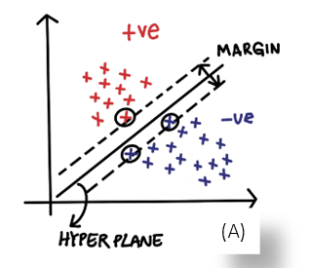
Observe the picture (B) both graphs in the picture represent the same data point but the hyperplane is drawn in different ways. We can see that the marginal distance (D_1) is greater than (D_2). So here in this example, the most efficient hyperplane is the one with marginal distance (D_1).
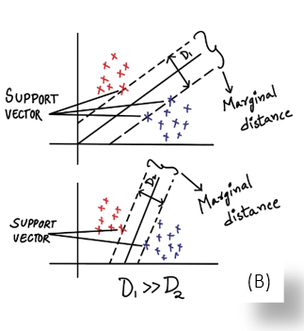
As shown in picture C.1, there are data points represented on a straight line where positive points are sandwiched between negative. Here it is impossible to classify negative and positive points in two different classes using a hyperplane. By using the polynomial kernel, we convert 1D to 2D which means we map points from the straight line to a polynomial (as shown in C.2). As shown now after implementing polynomial kernel we can easily classify the negative and positive points using a straight line (hyperplane).
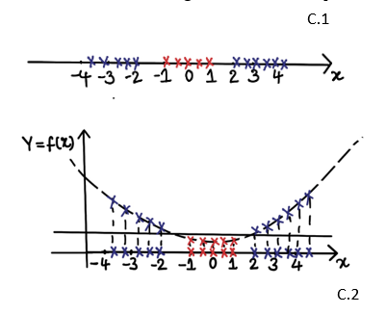
- Random Forest
Random Forest is a learning method that employs the construction of multiple decision trees to achieve its results. The random forest makes the final decision, which is based on many of the trees. There are numerous advantages to using the Random Forest Algorithm, but one of the most significant is that it minimizes the risk of overfitting and the amount of training time required. Furthermore, it has a high level of accuracy. In large databases, the Random Forest algorithm operates efficiently and produces very accurate forecasts by estimating data lacking.
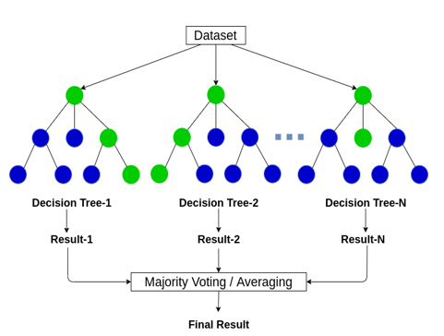
A decision tree is a diagram that depicts the various consequences of a set of connection choices. The visualization of the decision tree requires a tree-shaped diagram to draw a plan of action or to analyze the mathematical likelihood. It's used to deconstruct complicated problems or branches. Each branch of the decision tree may lead to a different result.
Entropy: It is an indicator of the data set's randomness or unpredictability.
Information gain: It is a calculation of the decline in entropy after splitting the data collection.
Leaf node: it is a decision-making node.
Root node: it is the topmost decision node, where all your data is available.
Let us presume we want to categorize the various types of fruits in a bowl based on various characteristics, but the bowl is cluttered with several choices. We build a training dataset with details about the fruits, such as colors, diameters, etc. After that, we then must divide the data by arranging the smallest part so that it is split as far as possible. We would want to divide the fruits first by diameter, then by color. We want to keep splitting until that node no longer requires it and accurately forecast a single fruit and consider it as tree 1 and later with different choices, we build another decision tree, and so on. The greater number of trees the better the random forest works. Many of these trees are the results of random forests.
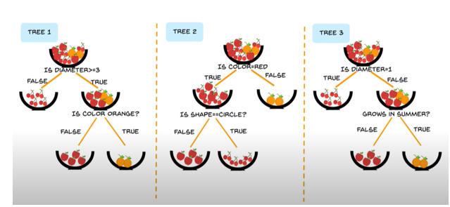
- Method explanation
Tkinter: In order to create a Graphical user interface GUI tool kit create an interface object by using the import statement as like in java util packages such as date and time functions
File dialog: asks Save as filename, ask open file, ask directory here we used an open file to read data.
NumPy: NumPy is a python library working with arrays. We can use a list, tuple, and dictionary but it is 50times fast compared to those other data types.
Pandas: Diverse range of utilities, ranging from parsing multiple files formats to converting an entire data table into NumPy matrix array as x.txt/npy as image features and y.txt/npy as index label of images
Dialog box: adding widgets in this application we use the button in the GUI window.
Message box: After uploading an image it has to show a message either loaded or else empty (shows user successful or not)
Cv2: Solve computer vision problems cv2.imread() method loads image to read cannot mean return an empty in matrix index array number.
SVM: classification and regression challenge and classification problems.
Train_test_split: Do not need to split manually train and testing the data array. By default, will make isolation into two subsets.
Sklearn. metrics: the set labels predicted for a sample must exactly match the corresponding set of values and detect the error.
RandomForestClassifier: Predicting the tree decisions based on the datasets.
PCA: reduce the dimensionality into singular value computing the covariance matrix with an eigenvector.
Matplotlib: Mathematical support to NumPy and function manipulate figure elements, creating, plotting area, lines, and labels, etc.
Here in the project, we define three functions.
upload (): open the file and read test images and shows message box image file loaded. At bottom of the main loop termination, we use to call these functions when we hit the upload button it calls the upload () function and returns a successful or else empty matrix.
generate the model (): Here we test and train the image based on the features and index values and we saved in the x.txt.npy and y.txt.npy and calculate accuracy scores based on the predictions of class from sklearn. metrics of accuracy reshaping of the image as per the dataset we used. And according to the graphical user interface, the ratios should set to the window size _score. Test and generate in GUI mode when we hit the button and it calls generate functions and calculate error percentage based on the values and show graph in the windows.
classify (): Here we open the image files based on cv2 and resize and predict based on the index number after testing and training it matches with our functions ‘0’means car like that. Finally, here it classifies the images based on the user interfaces and finally hits on the exit button it exits.
- MNIST Dataset
Dataset consists of numbers from 0 to 9 for each number you have thousands of images for each class and these classes are 0,1,2,3 soon. Test and train like four files will be there we have to train and test images and store in array form in NumPy. The urinary string file is converted into binary form based on the 32 bits(4bytes) we can decide if the first four bits give a magic number of the 2049 Test set label of features of the images. The next four gives a number of items and the next eighth bit onwards it gives the index base value. Then first four bits of 2051 magic numbers give the image file the next eight numbers of images then the following four gives pixel of rows and column. Here 16th bit gives pixels of images. And we stored in a file of model for future purpose every time need not be tested and train the images and we upload the files in generating model by declaring global variables.
- Software Interference
The required software in python.
HARDWARE REQUIREMENTS:
• Processor - Pentium
• Speed - 1.1 GHz
• RAM - 256 MB
• Hard Disk - 25GB
• Keyboard - Windows Keyboard
• Mouse - Three Button Mouse
• Monitor - Super Video Graphics Array
SOFTWARE REQUIREMENTS:
• Operating System - Windows 7/8/10
• Programming Language - Python IDE
- UML diagram
The Unified Modeling Language permits the software engineer to express an evaluation version of the usage of the modeling notation this is ruled by way of a fixed of syntactic-semantic and pragmatic policies.
A collection diagram is a sort of interplay diagram that shows how strategies function with each other and in what order. It is a assemble of a Message Sequence Chart. A collection diagram indicates object interactions arranged in time series. It depicts the gadgets and instructions concerned in the scenario and the series of messages exchanged among the gadgets needed to carry out the capability of the state of affairs. Sequence diagrams are generally associated with use case realizations within the Logical View of the machine beneath improvement. Sequence diagrams are occasionally known as event diagrams, event situations, and timing diagrams. figure (1)
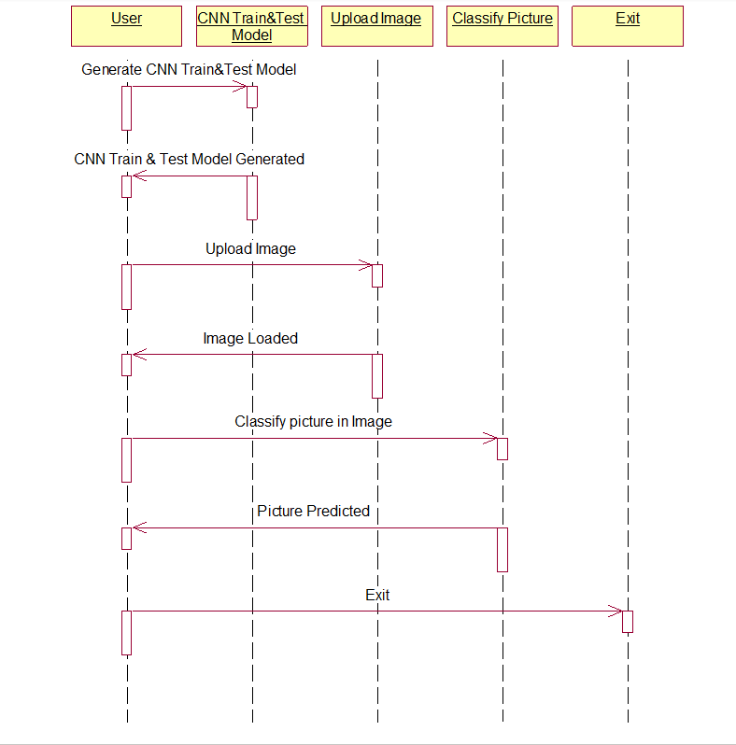
- Conclusion and Future work
In this paper, we used machine learning algorithms like SVM and Random Forest for image classification using images from handwritten MNIST data sets. These data sets used both and training and testing purposes using SVM and RF. It provides an accuracy rate of 98%. Images used for the training purpose are small and Grayscale images. The computational time for processing these images is very high as compared to other normal JPEG images. Stacking the model with more layers and training the network with more image data using clusters of GPUs will provide more accurate results of the classification of images. The future enhancement will focus on classifying the colored images of large size and it's very useful for the image segmentation process.
- References
- TÃ³th, B.P. and Czeba, B., 2016, September. Convolutional Neural Networks for Large-Scale Bird Song Classification in Noisy Environment. In CLEF (Working Notes) (pp. 560-568).
- Fagerlund, S., 2007. Bird species recognition using support vector machines. EURASIP Journal on Applied Signal Processing, 2007(1), pp.64-64.
- Pradelle, B., Meister, B., Baskaran, M., Springer, J. and Lethin, R., 2017, November. Polyhedral Optimization of TensorFlow Computation Graphs. In 6th Workshop on Extreme-scale Programming Tools (ESPT-2017) at The International Conference for High Performance Computing, Networking, Storage and Analysis (SC17).
- Cirean, D., Meier, U. and Schmidhuber, J., 2012. Multi-column deep neural networks for image classification. arXiv preprint arXiv:1202.2745.
- AndrÂ´eia Marini, Jacques Facon and Alessandro L. Koerich Postgraduate Program in Computer Science (PPGIa) Pontical Catholic University of ParanÂ´a (PUCPR) Curitiba PR, Brazil 80215901 Bird Species Classication Based on Color Features
- Image Recognition with Deep Learning Techniques ANDREI- PETRU BRAR, VICTOR-EMIL NEAGOE, NICU SEBE Faculty of Electronics, Telecommunications & Information Technology Polytechnic University of Bucharest.
- Inception-v4,Inception-ResNetand the Impact of Residual Connectionson Learning Christian Szegedy, Sergey Ioffe,Vincent Vanhoucke ,Alexandrr A.Alemi
- Stefan Kahl, Thomas Wilhelm-Stein, Hussein Hussein, Holger Klinck, Danny Kowerko, Marc Ritter, and Maximilian Eibl Large-Scale Bird Sound Classification using Convolutional Neural Networks
- Bo Zhao, Jiashi Feng Xiao Wu Shuicheng Yan A Survey on Deep Learning-based Fine-grained Object Classication and Semantic Segmentation
- Yuning Chai Electrical Engineering Dept. ETH Zurich,Victor Lempitsky Dept. of Engineering Science University of Oxford, Andrew ZissermanDept. of Engineering Science University of Oxford BiCoS:A BiSegmentation Method for Image Classication.
- Output

